Gastroenterology Referral Form

Patient details:
First name: Surname:

Address:

State: Postcode:

Phone: DOB:

Request:
O Consultation O Colonoscopy O Gastroscopy

Current medications and alerts:



MBBS BMedSci FRACP
Provider No. 264383UF

O Diabetes - on tablets or insulin (please circle)
O Anticoagulants - warfarin, Plavix, Xarelto, Eliquis, other O Renal impairment

Clinical details:

Referring Doctor’s details:
Doctor’s name: Address:
Phone: Provider number:

Signature: Date:

Phone: 07 3193 0877 Fax: 07 3319 6466 Email: reception@drjasonhuang.com.au www.drjasonhuang.com.au

Locations:
St Andrew’s War Memorial Hospital Sessional Suites, Level 4
457 Wickham Terrace
Brisbane QLD 4001

Holy Spirit Northside Private Hospital Arnold Janssen Building, Suite 15, Level 1 627 Rode Road
Chermside QLD 4032

Correspondence: PO Box 206, Ashgrove QLD 4060

For all appointments please call: 07 3193 0877

Locations:

St Andrew’s War Memorial Hospital Sessional Suites, Level 4, Yellow lifts, 457 Wickham Terrace
Brisbane QLD 4001
Holy Spirit Northside Private Hospital Arnold Janssen Building, Suite 15, Level 1 627 Rode Road
Chermside QLD 4032

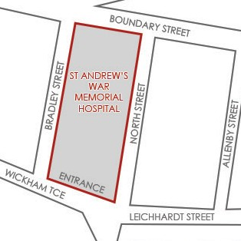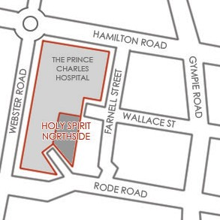

Notes:

